**Project Report**

**On**

**Child Care Center Network Design**

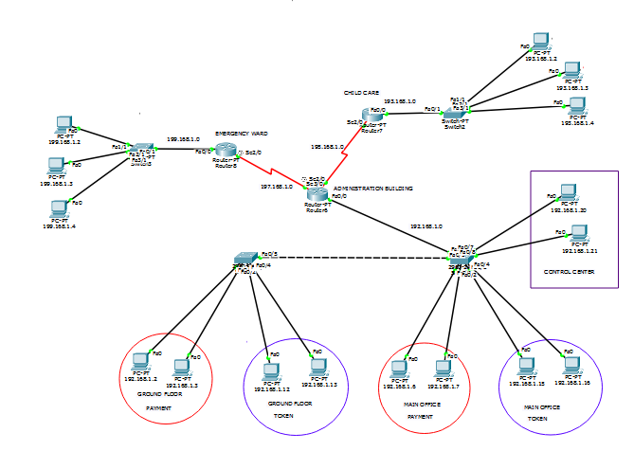

**TABLE OF CONTENT**

1. Abstract
2. Introduction
3. Details Of Project
4. Snapshot all codes
5. Dicision
6. Future plan
7. Conclusion

**ABSTRACT**

Child care center is method of service. Intension in this project to help people. In this network design people easily get all things. Also organization give proper service to the people. This makes the system modernized and help to people.

**INTRODUCTION**

Automatic multistoried child care network design helps to minimize the child care center area. In this modern world network design is very important in every sector. Here people contact administration building and get all information. People and center organization both are getting benefit in this network design.

**DETAILS OF PROJECT**

In this care center has three building. Administration building, emergency ward and child care. Administration building has three part, there are ground floor, main office and control center. ground floor and main office control payment and token sytem. Firsty ground floor pass the message to main office for payment and token confirmation. secondly control center connected with emergency ward and child care. When any emergency case then control center pass message to emergency ward. When normal case then control center message to child care.

**TOOl:**

1. Static Routing
2. Dynamic Routing
3. Vlan

**Requirements:**

1. Sixteen Pc
2. Four Switch
3. Three Router
4. Connecting wire

**Diagram:**

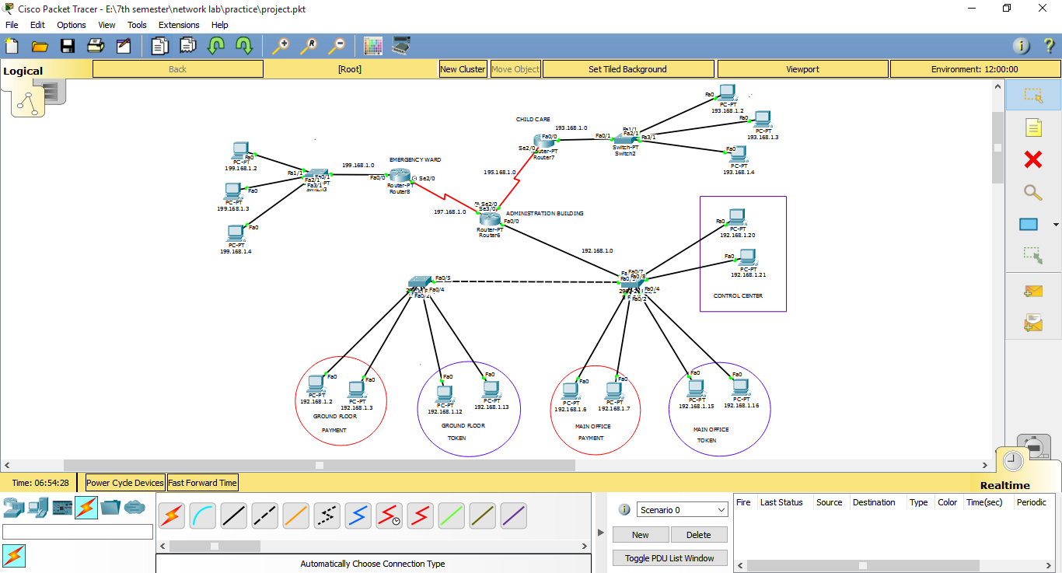

**SNAPSHOT ALL CODES**

Configuration all PC :- Here some screen shot

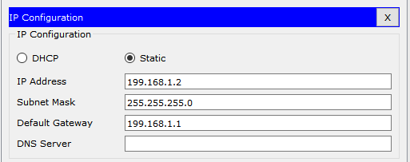

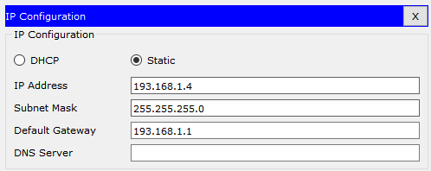

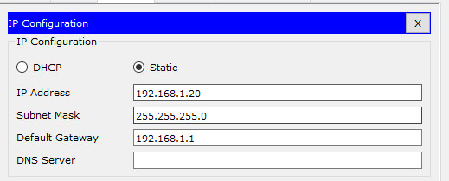

* **Static Routing**

For Router8

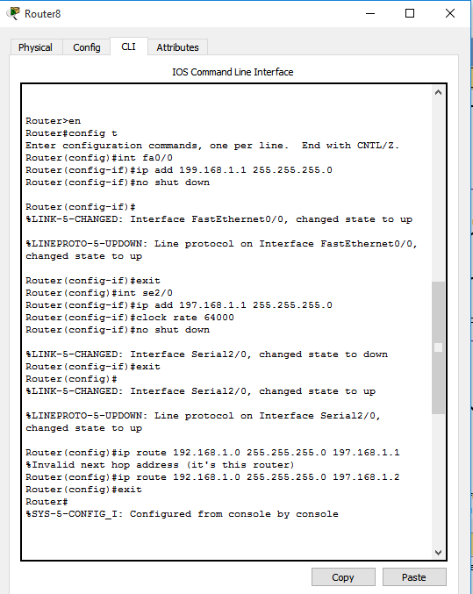

For Router6

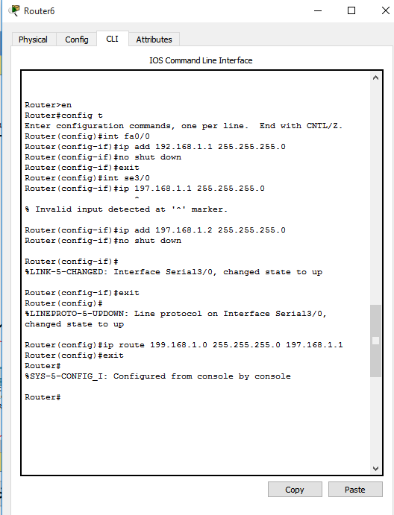

* **Dynamic Routing**

For Router7

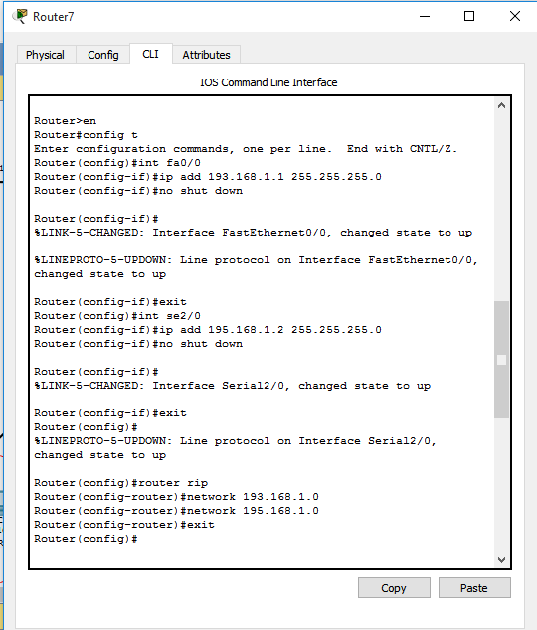

For Router6

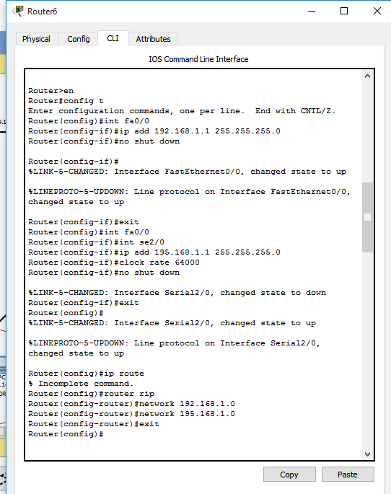

* **VLAN**

For Switch 1

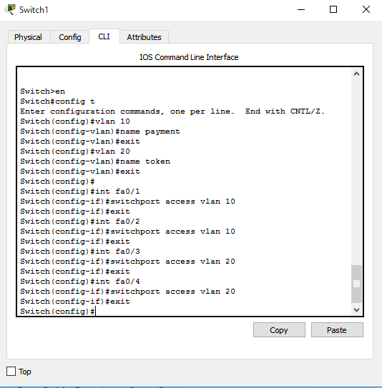

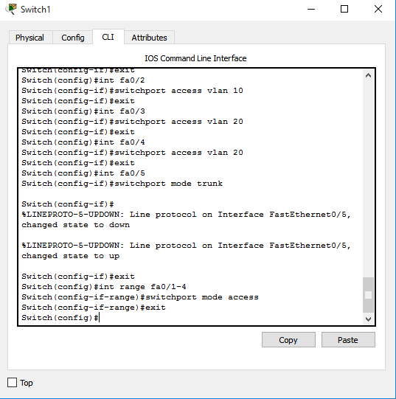

For Switch 0

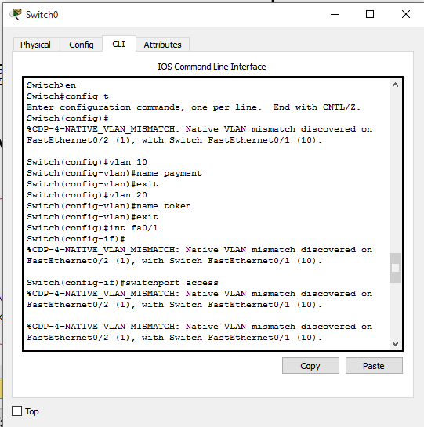

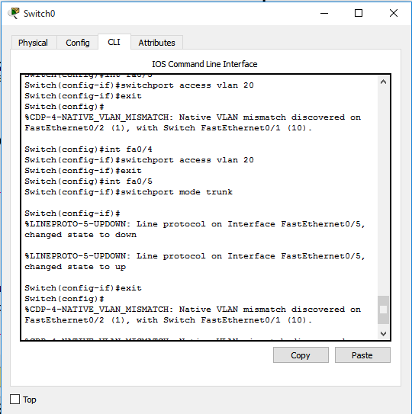

**DICISION**

Successfully message passed from Administration to Emergency ward in Static Routing .

Successfully message passed from Administration to Child care in Dynamic Routing.

Successfully message passed Payment and Token.

**FUTURE PLAN**

This network design is a small child care center network design. We add more three or four building using router and switch. When we add more building then Child care center convert into Child Care Hospital Network Design.

**CONCLUSION**

In this modern world network design very is important. It is helpful for us. This network design is basically made using the idea of Static Routing, Dynamic Routing And Vlan.